# Translation of Mod

## 1.Brief

To translate Xml files, you need to translate Chinese in the translate file, which is exported by StringTool.exe in the Mods folder.

For lua files, you should exchange ”Chinese” to XT(“Chinese”)

And add translation relations in the Language/OfficialEnglish/MapStoryDictionary.txt

If you need to translate other things, please rename your translated files to the corresponding names in the OfficalEnglish folder.

## 2.xml translation

### 2.1 Tool instruction

Step 1: Enter the to-be-translated folder name

Step 2: Press the button and wait for the program executing complete

Step 3: After it is complete, there will be a complete window and then press OK.

Step 4: Translated folder will automatically open after Step 3.

Step 5: Translated all Chinese into English in the to-be-translated folder. In the example below, the 测试狮子 is translated to ModTestBdName. Then translation is done.

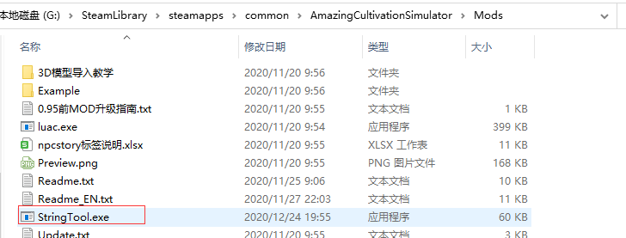

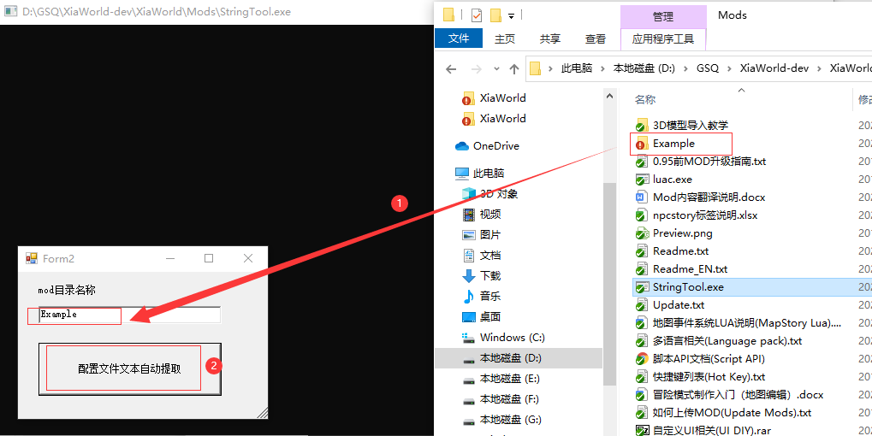

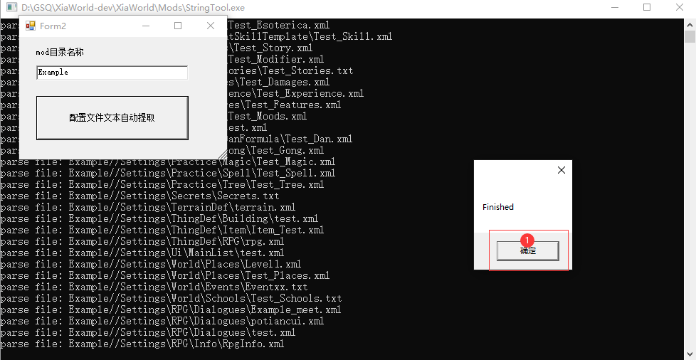

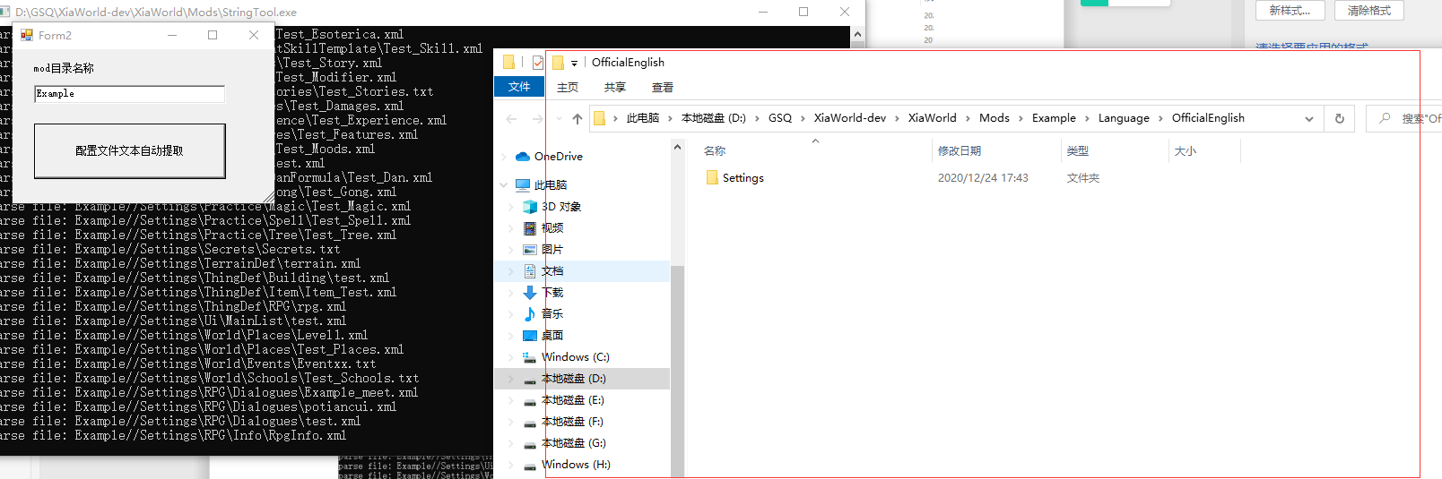

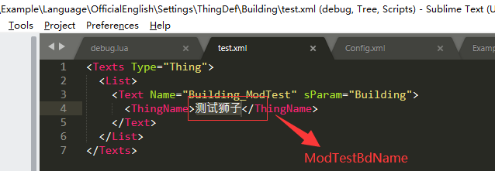

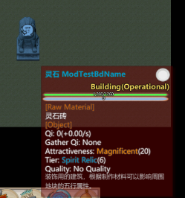

### 2.2 Deal with Errors

Console in the tool will show the file name which is working on. If there shows some errors, you can check that whether there is format errors in the last file showed in the console.

[If you cannot solve the errors, you can compress your file and email it to us at qa@gsqstudio.com .](mailto:工具的控制台里会输入当前正在处理的文件名，如果出现报错，可以查看控制台的最后一个文件里是否有格式错误。如果无法解决，可以通过把配置文件压缩以后，通过qa@gsqstudio.com联系我们)

The example below is an error that the file has a wrong annotation format. After it is corrected, the program runs successfully.

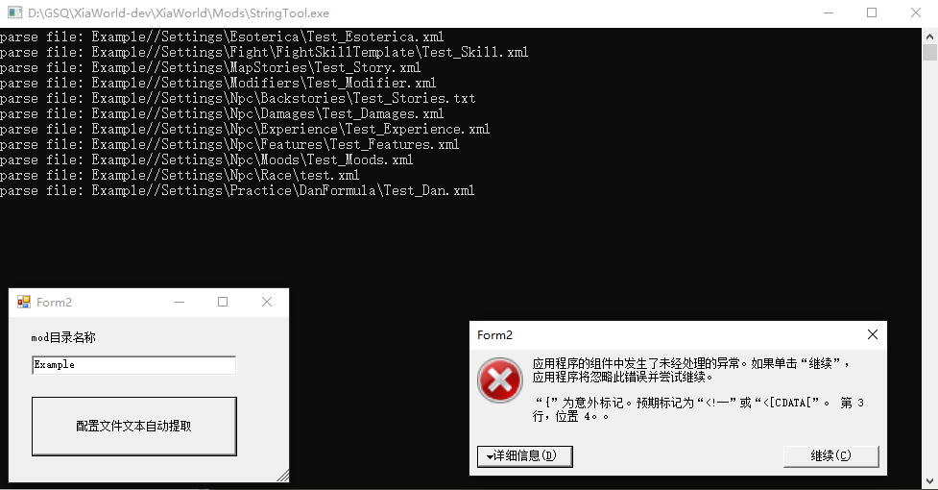

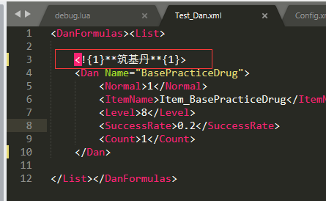=>

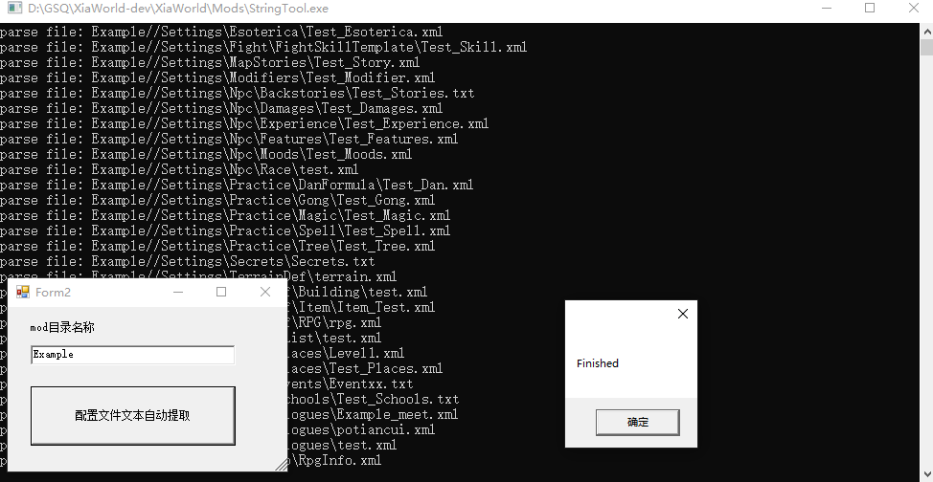

## Lua Translation

Here is an example of Lua Translation, which is a miracle in the game.

Now we want to change the window content after casting the miracle.

### Change Lua script

Change “中文” to XT(“中文”)

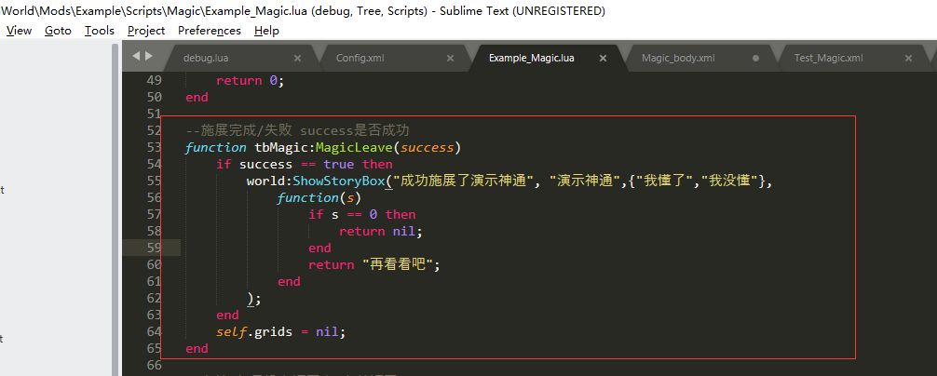

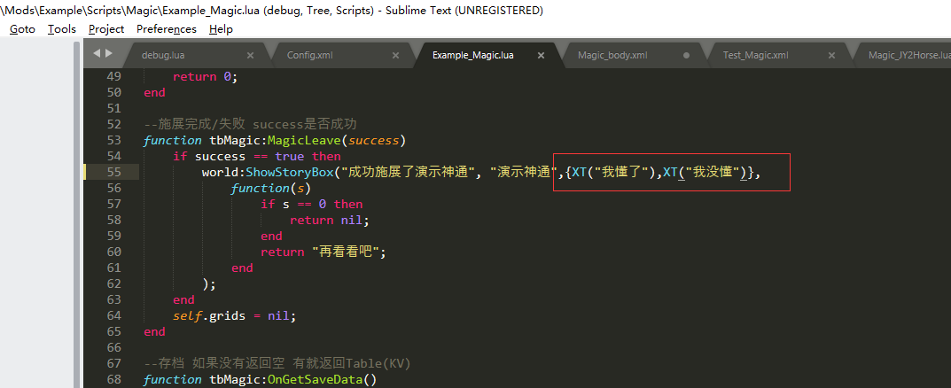

### 3.2 Write down Chinese-English responding Relations in the MapStoryDictionary.txt

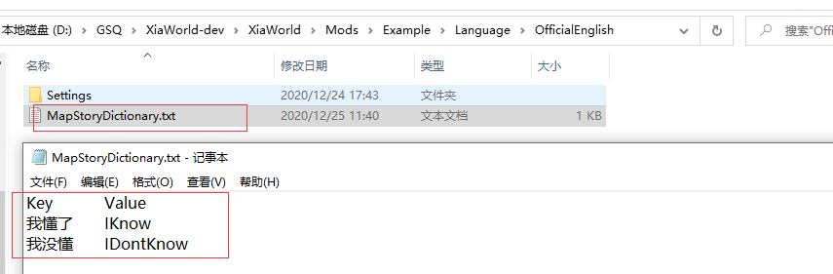

### 3.3lua Translation successfully, shows below.

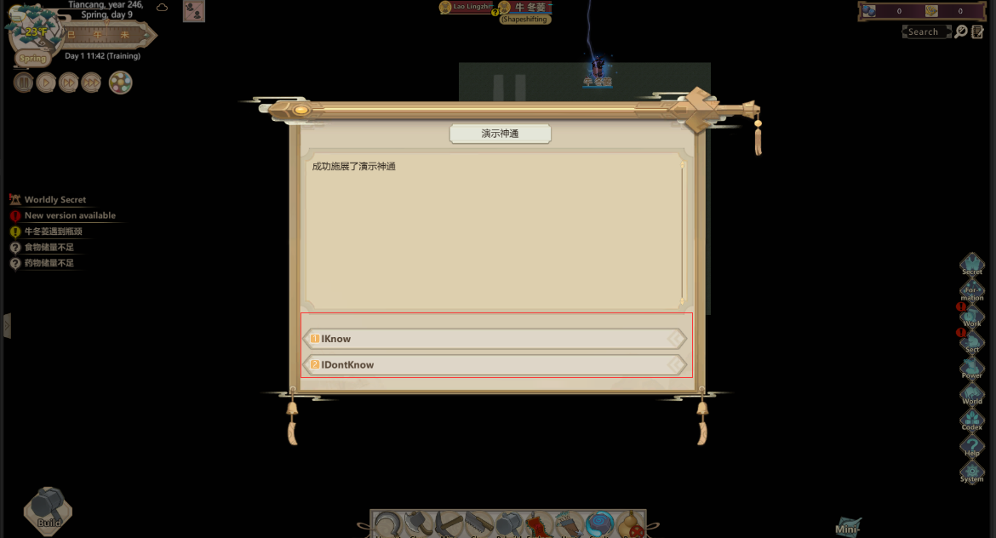

## Translation for other contents

Translation files exported by the tool will be created in the folder Language/OfficialEnglish. So does Lua files. This folder is a mod folder of official English translation.

If you want to translate mods to other languages, you can rename the OfficalEnglish folder to what you want.

For example: If you want to use EnglishSource in the Example folder as a translation source, you should rename Official English to EnglishSource.